TERRAFORM – TASK – 06
==========================================================
Title
Terraform Workspaces with AWS EC2 Deployment (Dev / Staging / Prod)
Objective
To deploy multiple AWS EC2 instances for different environments (dev, staging, prod) using Terraform Workspaces, and manage separate infrastructure state for each workspace in the same Terraform project.
Prerequisites
1. AWS account with valid access keys configured using AWS CLI (aws configure)
2. Terraform installed and verified using terraform -v
3. VS Code installed for editing .tf files
4. IAM user/role with permissions for EC2, VPC, Subnet, Security Group
5. Basic Terraform knowledge (init, plan, apply, workspaces)
6. Correct AWS region selected (example: eu-north-1)
Error Faced Error: Invalid index during terraform plan
This happened because the workspace name did not match the keys inside the local maps (example: instance_type_map[local.env]).
How I Fixed It 1. Verified the workspace name using: terraform workspace show
2. Created correct workspaces matching the map keys:
terraform workspace new dev
terraform workspace new staging
terraform workspace new prod
3. Switched workspaces when required using:
terraform workspace select dev/staging/prod
4. Ran Terraform commands again:
terraform plan and terraform apply
5. Verified successful creation by checking outputs like environment, instance_type, and public_ip
Conclusion
Successfully created separate EC2 instances for dev, staging, and prod using Terraform Workspaces. Each workspace maintained its own separate state file, and resources were verified in the AWS EC2 Console, confirming environment-based deployments were working correctly

2.Execute the script shown in the video.

- Open VS Code and create a project folder: TERRAFORM_PROJECT
- Inside it, create a folder named aws_instance
- Inside aws_instance, create these files:
  - main.tf
  - variables.tf
- In main.tf, write the EC2 resource block and use variable for AMI:
  - ami = var.ami
  - instance_type = "t3.micro"

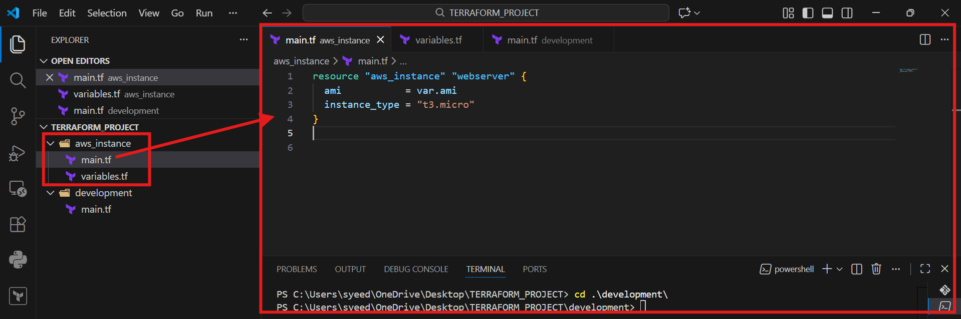
- Open aws_instance/variables.tf
- Create a variable for AMI like:
  - variable "ami" { }
- Save the file

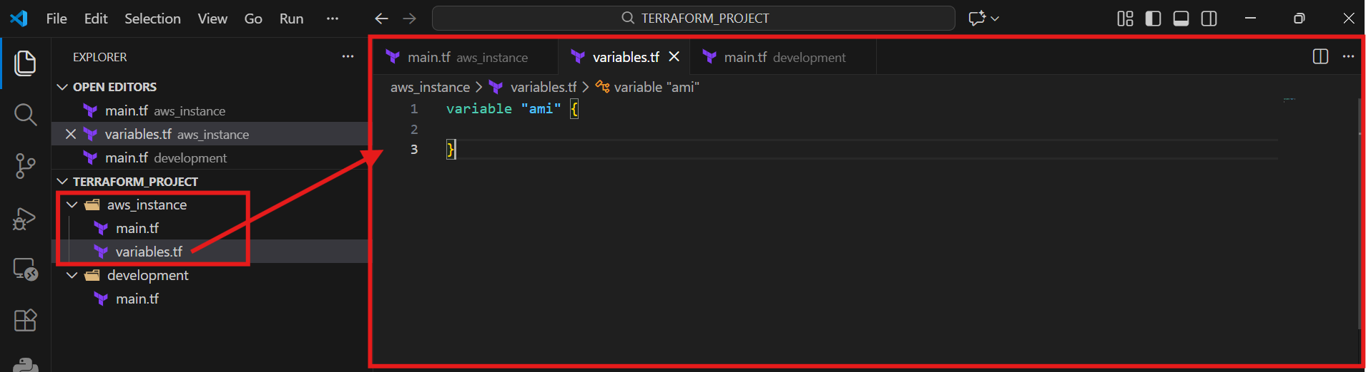
- Create a new folder in project: development
- Inside development, create main.tf
- In development/main.tf, call the module:
  - module "dev-webserver" {
  - source = "../aws_instance"
  - ami = "ami-xxxxxxxxxxxx"
  - }

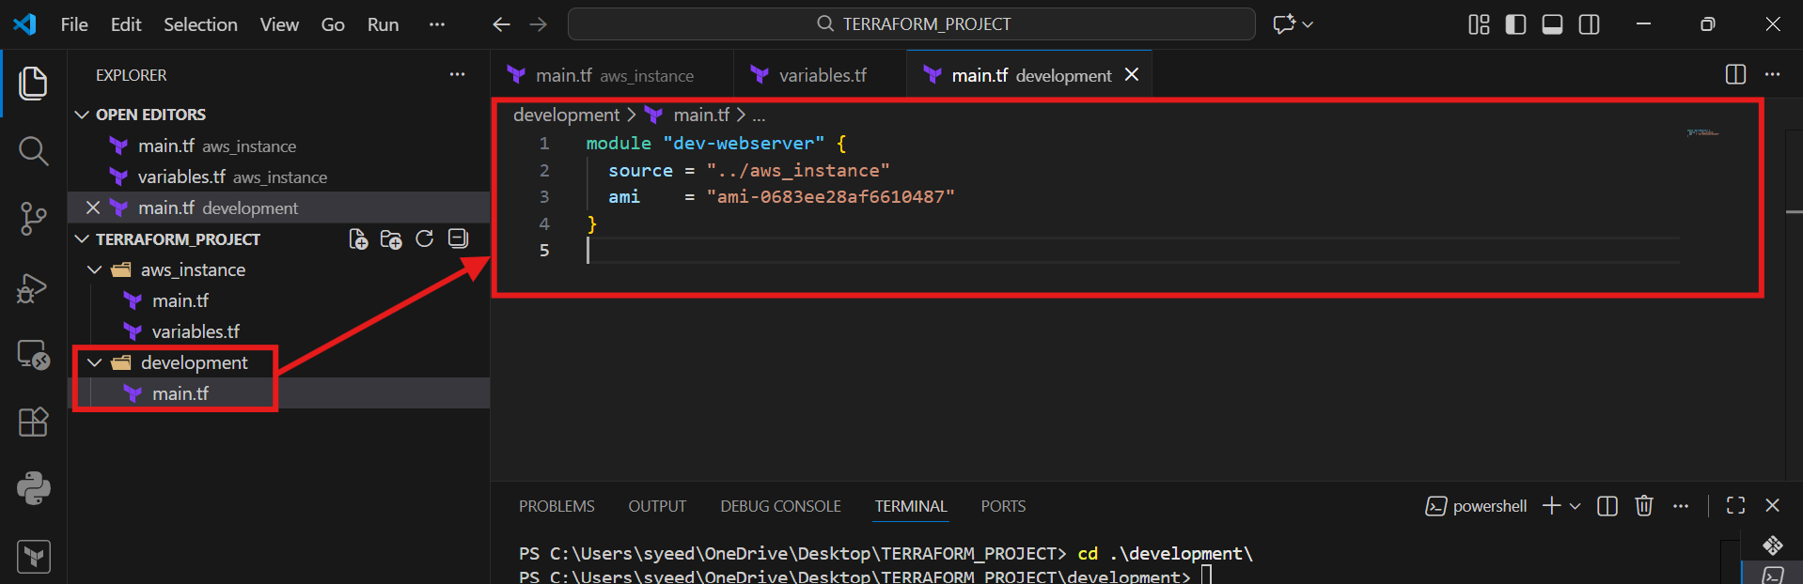
- Open terminal in VS Code
- Go to development folder:
- cd .\development\
- Run Terraform initialization:
- terraform init
- Confirm message: Terraform has been successfully initialized

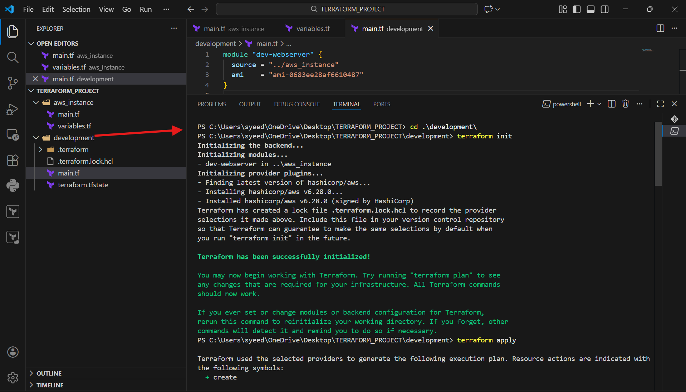
- Run Terraform apply:
- terraform apply
- Review plan: Plan: 1 to add, 0 to change, 0 to destroy
- Type:
- yes
- Wait until it shows Creation complete
- Instance is successfully created

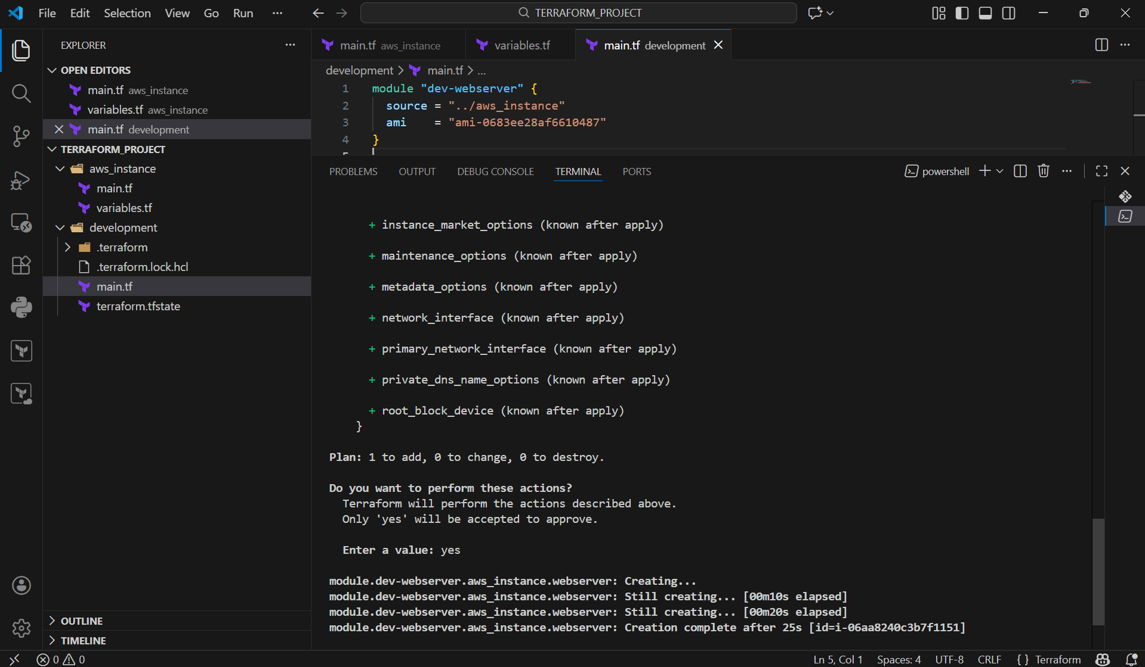
- Open AWS Console
- Go to EC2 → Instances
- Check your instance state is Running
- Verify AMI ID and Instance Type (t3.micro)

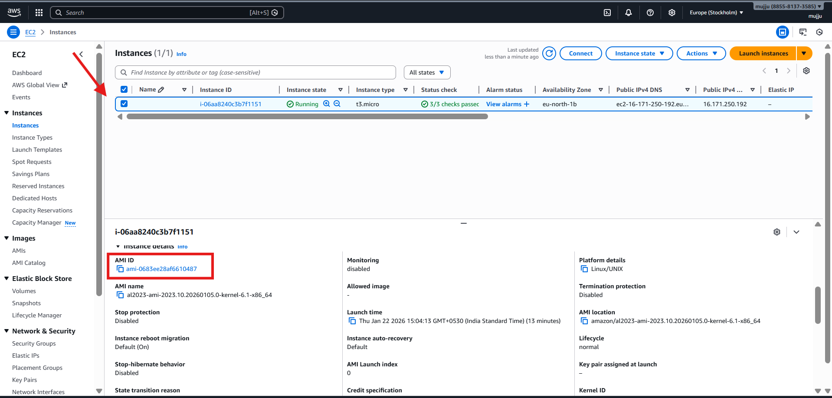

- In terminal (project root), create new workspace:
terraform workspace new projectA
- List workspaces:
terraform workspace list
- Switch workspace:
terraform workspace select default
terraform workspace select projectA

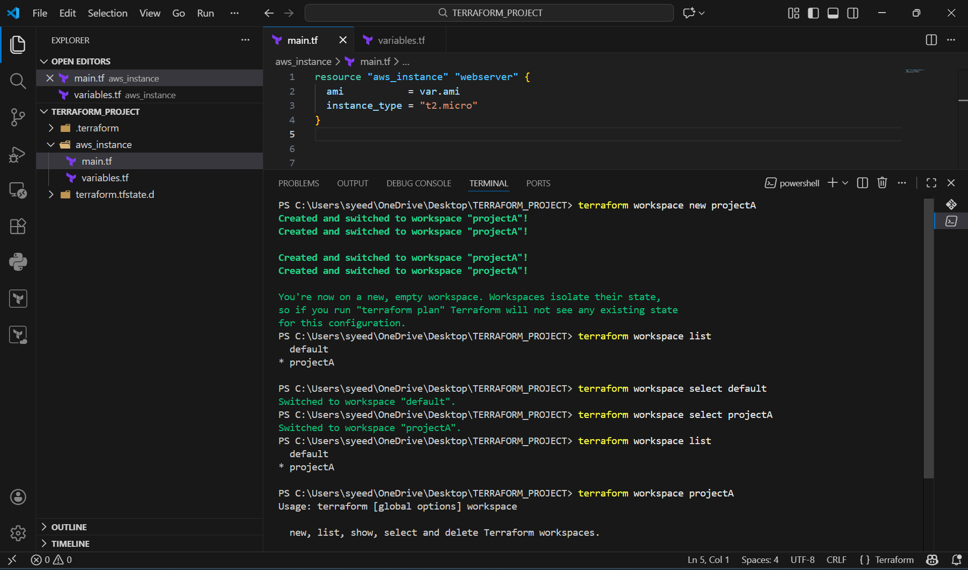
- Update variables.tf to use map:
type = map(string)
- Add AMI values for each workspace like:
ProjectA = "ami-xxxx"
ProjectB = "ami-yyyy"

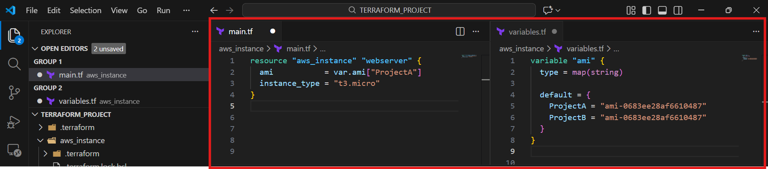
- Open terminal inside aws_instance folder
- Run:
- terraform init
- Run:
- terraform apply
- Terraform creates workspace-specific state file like:
- terraform.tfstate.d/projectA

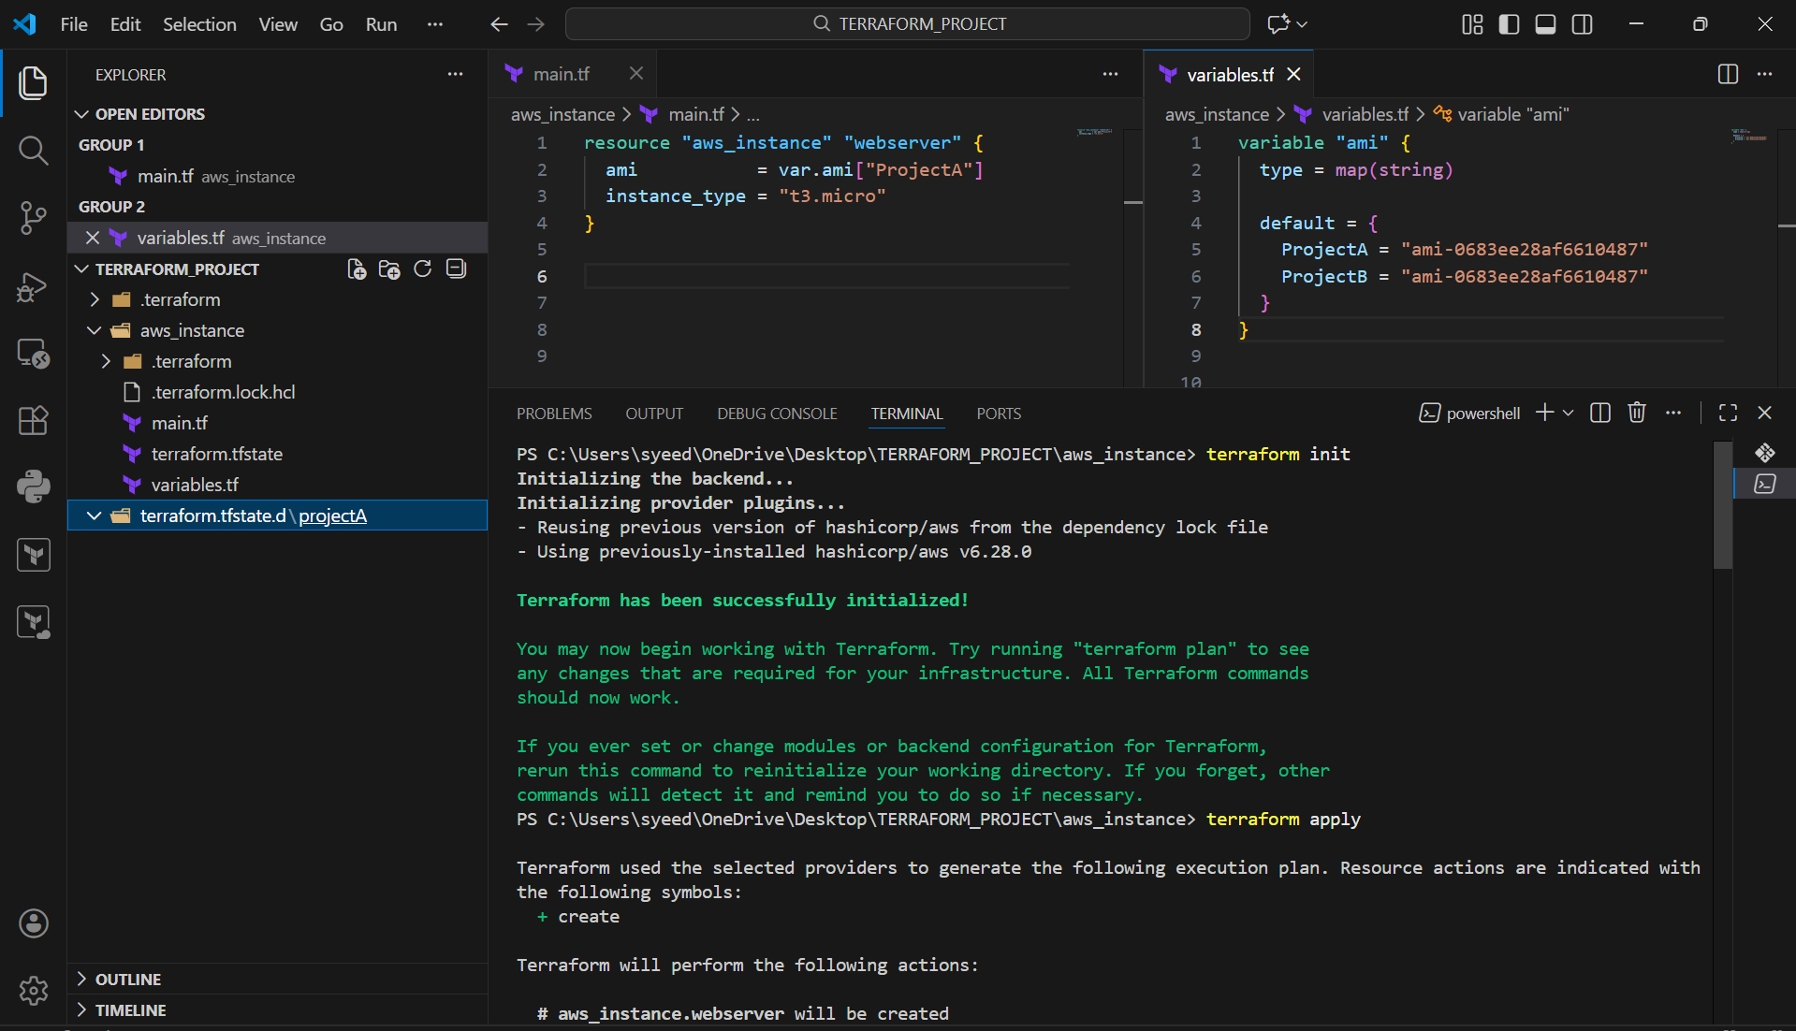
- After apply, verify output:
- Apply complete! Resources: 1 added, 0 changed, 0 destroyed
- Confirm in VS Code explorer:
- terraform.tfstate.d/projectA exists
- This confirms the workspace is managing separate state successfully

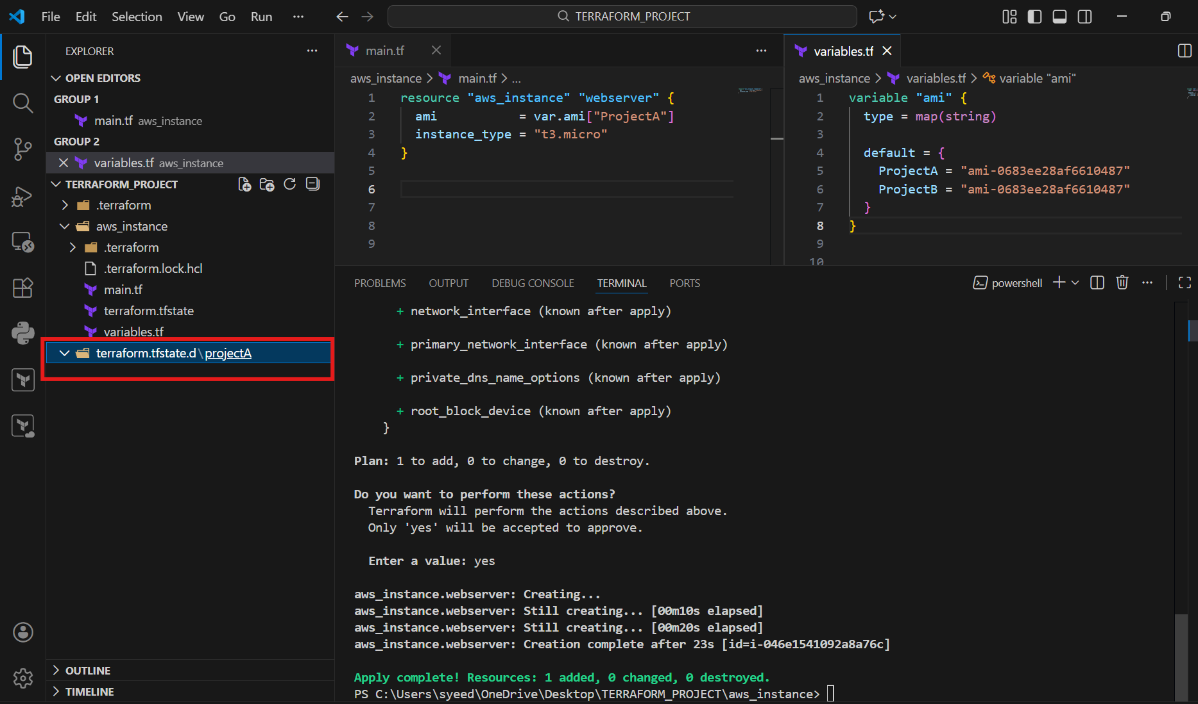

3.Provision EC2, S3, and VPC using Terraform modules.
terraform {
required_version = ">= 1.3.0"

required_providers {
aws = {
source = "hashicorp/aws"
version = "~> 5.63"
}
}
}

provider "aws" {
region = "eu-north-1"
}

# ----------------------------
# VPC MODULE
# ----------------------------
module "vpc" {
source = "terraform-aws-modules/vpc/aws"
version = "5.1.2"

name = "my-vpc"
cidr = "10.0.0.0/22"

azs = ["eu-north-1a", "eu-north-1b", "eu-north-1c"]

private_subnets = ["10.0.0.0/26", "10.0.0.64/26", "10.0.0.128/26"]
public_subnets = ["10.0.1.0/26", "10.0.1.64/26", "10.0.1.128/26"]

enable_nat_gateway = true
single_nat_gateway = true
enable_vpn_gateway = false

tags = {
terraform = "true"
environment = "dev"
}
}

# ----------------------------
# EC2 MODULE
# ----------------------------
module "ec2" {
source = "terraform-aws-modules/ec2-instance/aws"
version = "4.3.0"

name = "my-ec2"

ami = "ami-0683ee28af6610487"
instance_type = "t3.micro"

subnet_id = module.vpc.public_subnets[0]

associate_public_ip_address = true

tags = {
terraform = "true"
environment = "dev"
}
}

# ----------------------------
# S3 MODULE
# ----------------------------
module "s3" {
source = "terraform-aws-modules/s3-bucket/aws"
version = "4.1.2"

bucket = "mujju-1617"

tags = {
terraform = "true"
environment = "dev"
}
}

# ----------------------------
# OUTPUTS
# ----------------------------
output "vpc_id" {
value = module.vpc.vpc_id
}

output "ec2_public_ip" {
value = module.ec2.public_ip
}

output "s3_bucket_name" {
value = module.s3.s3_bucket_id
}

- Open VS Code → TERRAFORM_PROJECT
- Open main.tf
- Add Terraform block with:
required_version
required_providers (aws provider source + version)
- Configure AWS provider:
provider "aws" { region = "eu-north-1" }
- Add VPC module using Terraform Registry module:
module "vpc" { source = "terraform-aws-modules/vpc/aws" }
- Configure VPC module values:
name = "my-vpc"
cidr = "10.0.0.0/22"
Availability Zones: eu-north-1a, eu-north-1b, eu-north-1c
Public subnets + Private subnets CIDR blocks
NAT Gateway settings
- Start writing EC2 module block below the VPC module

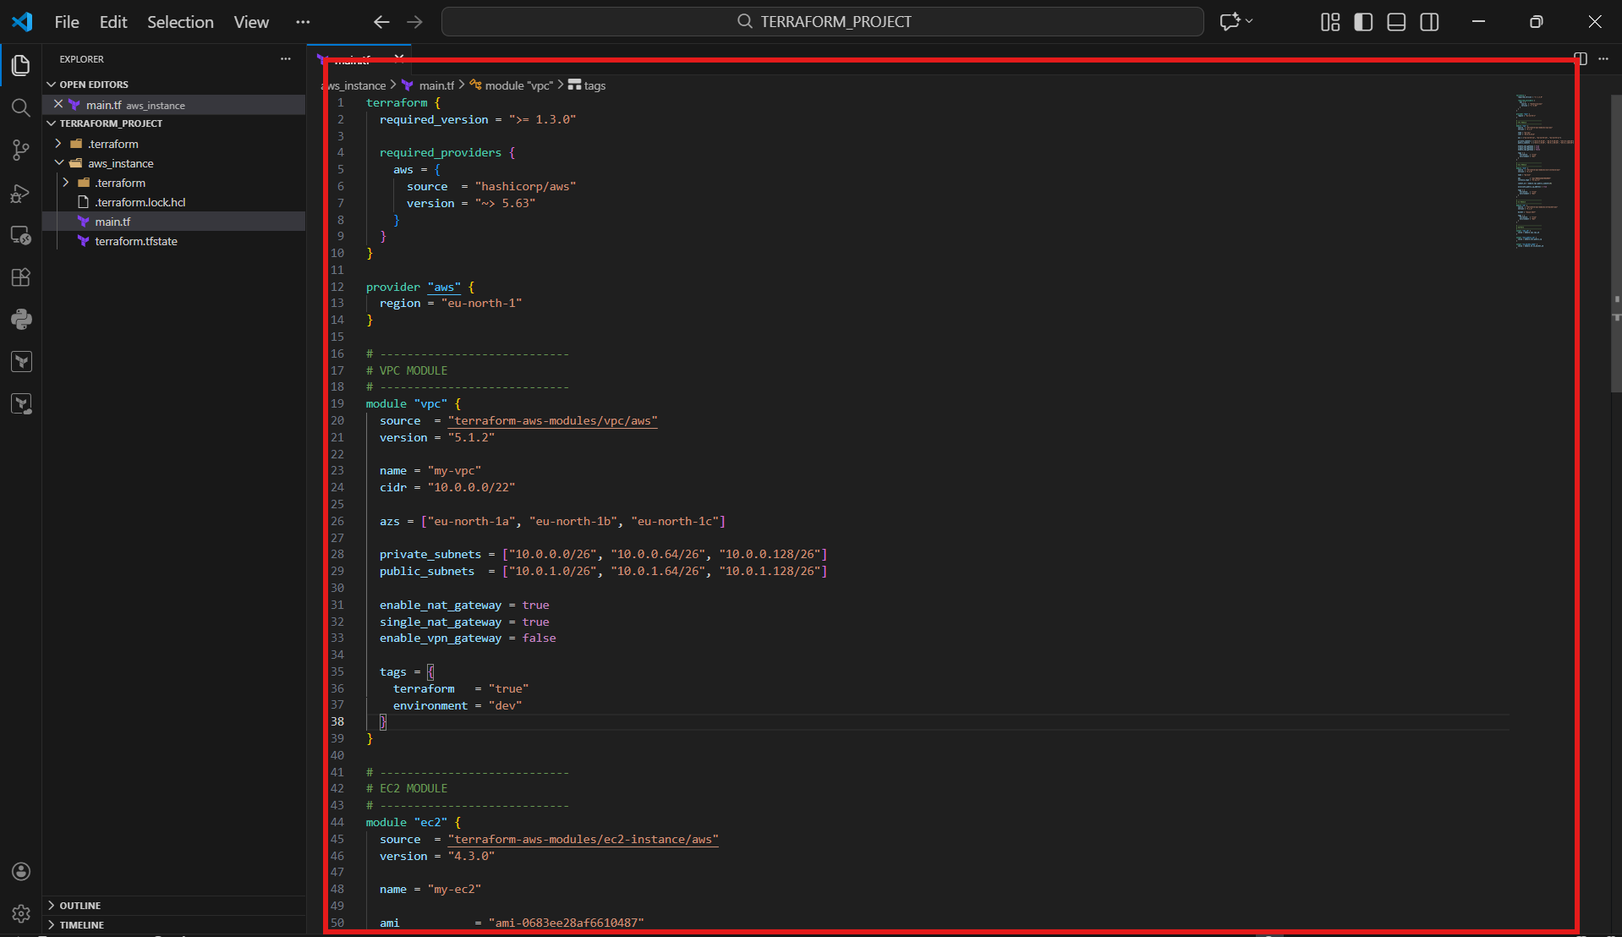
- Continue in main.tf
- Complete EC2 module:
module "ec2" { source = "terraform-aws-modules/ec2-instance/aws" }
- Set EC2 configuration:
ami = "ami-0683ee28af6610487"
instance_type = "t3.micro"
subnet_id = module.vpc.public_subnets[0]
associate_public_ip_address = true
- Add tags section (terraform + environment)
- Add S3 module:
module "s3" { source = "terraform-aws-modules/s3-bucket/aws" }
- Set bucket name:
bucket = "muji-1617" (your bucket name)
- Add outputs at the bottom:
output "vpc_id" { value = module.vpc.vpc_id }
output "ec2_public_ip" { value = module.ec2.public_ip }
output "s3_bucket_name" { value = module.s3.s3_bucket_id }
- Save the file

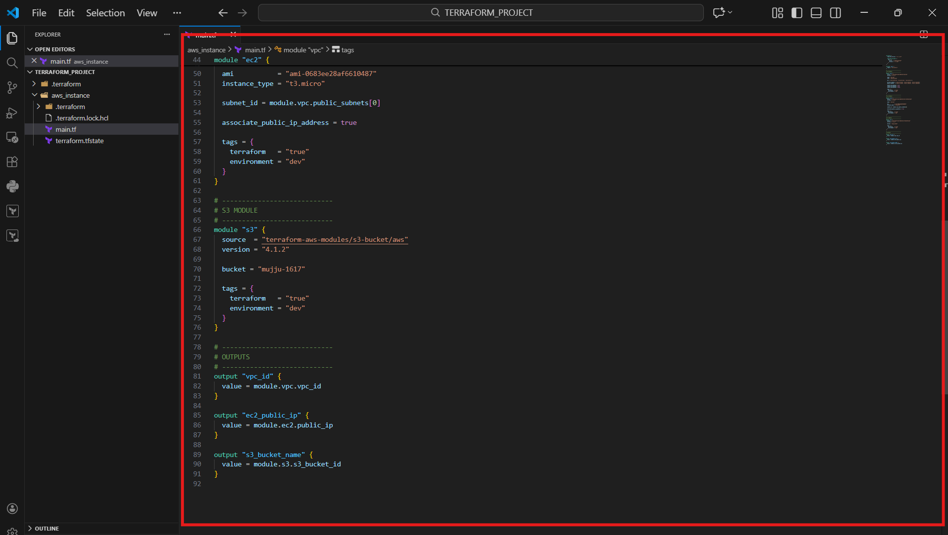
- Open terminal inside project folder
- Go to folder where main.tf exists (example: aws_instance)
- Run Terraform apply with auto approval:
terraform apply -auto-approve
- Terraform will:
Initialize modules
Read AWS identity/region info
Create execution plan (VPC + EC2 + S3)

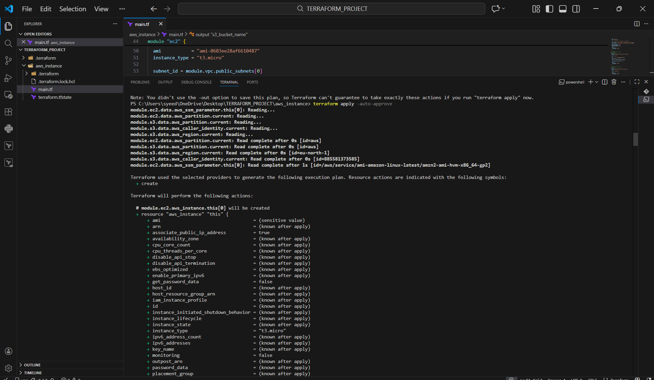
- After apply finishes, verify message:
Apply complete! Resources: added, changed, destroyed
- Check the Outputs section in terminal:
ec2_public_ip
vpc_id
s3_bucket_name
- This confirms VPC + EC2 + S3 modules were deployed successfully

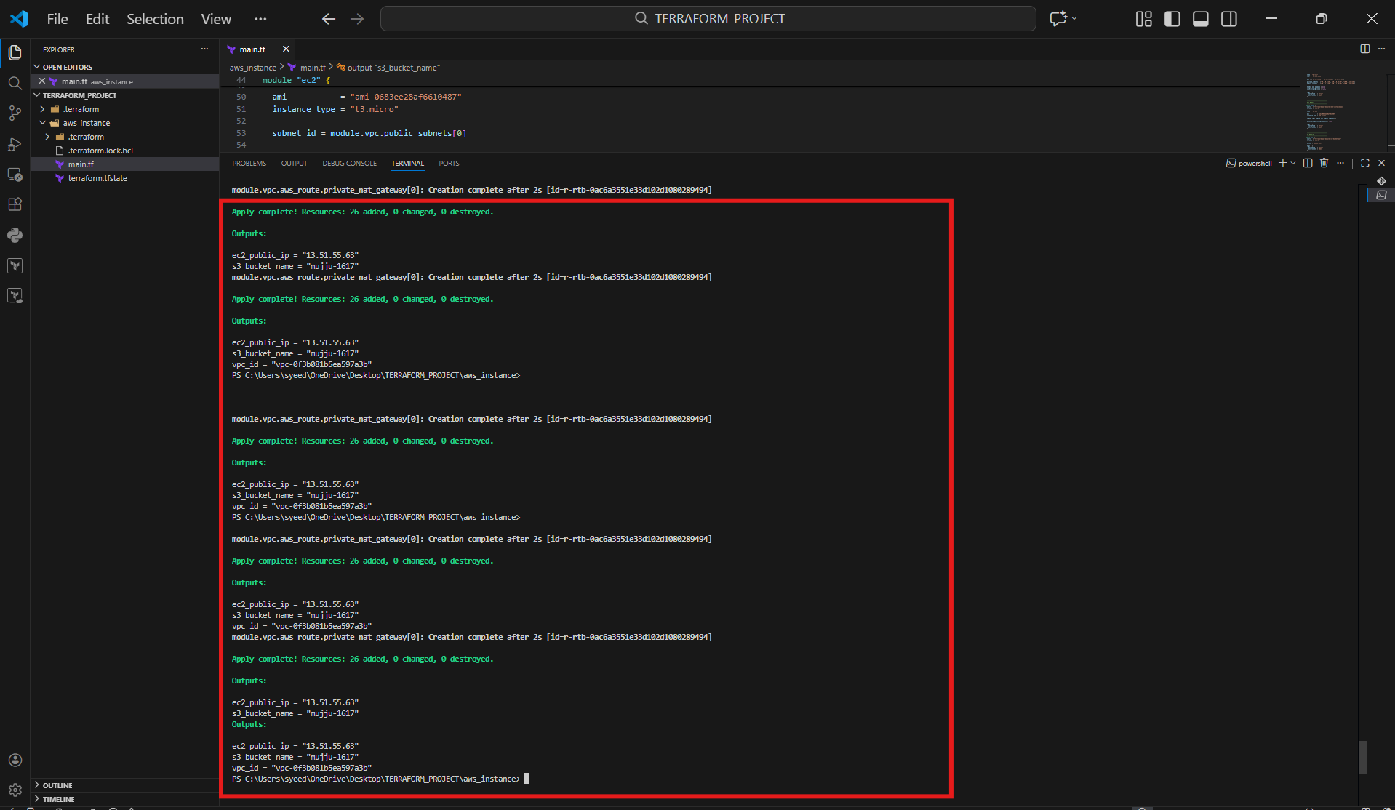
- open AWS Console
- Go to VPC → Your VPCs
- Verify the new VPC exists:
- Name: my-vpc
- Status: Available
- Confirm the VPC CIDR matches your Terraform code

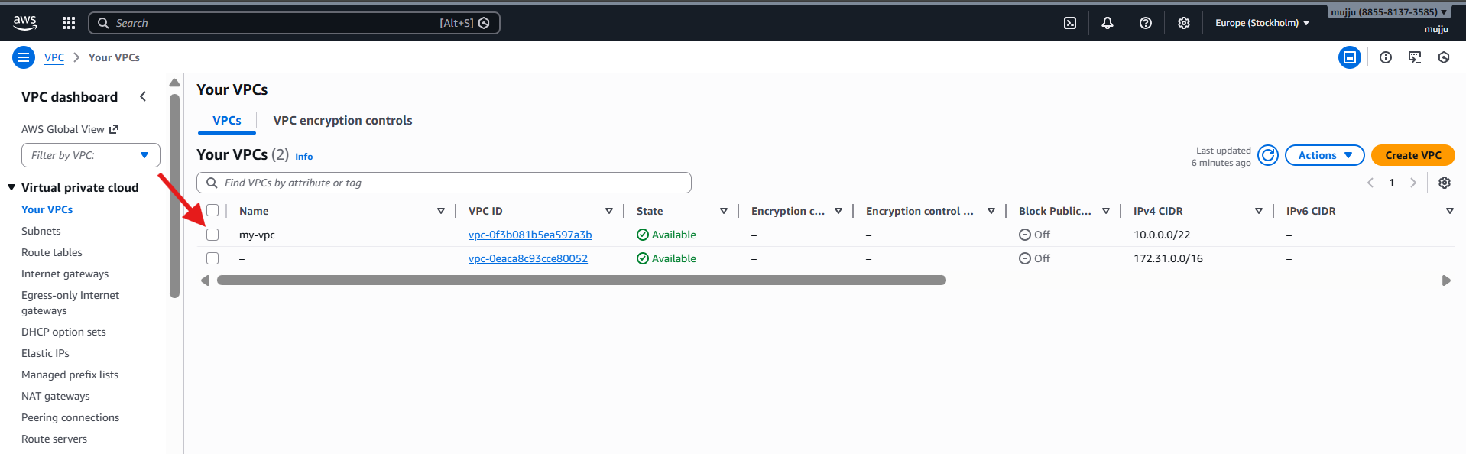
- Go to EC2 → Instances
- Confirm instance is Running
- Verify details:
- Name: my-ec2
- Instance type: t3.micro
- Public IPv4 address assigned
- VPC is my-vpc
- Subnet is one of the public_subnets

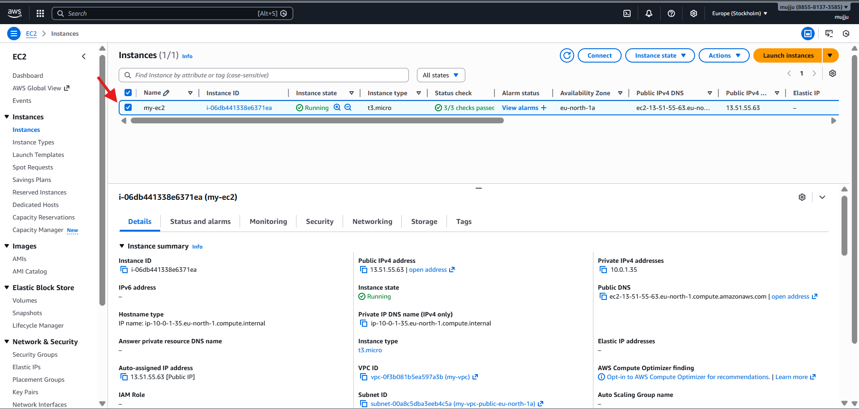
- go to S3 → Buckets

- Confirm bucket is created:

- Bucket name: muji-1617

- This confirms your Terraform S3 module is working properl
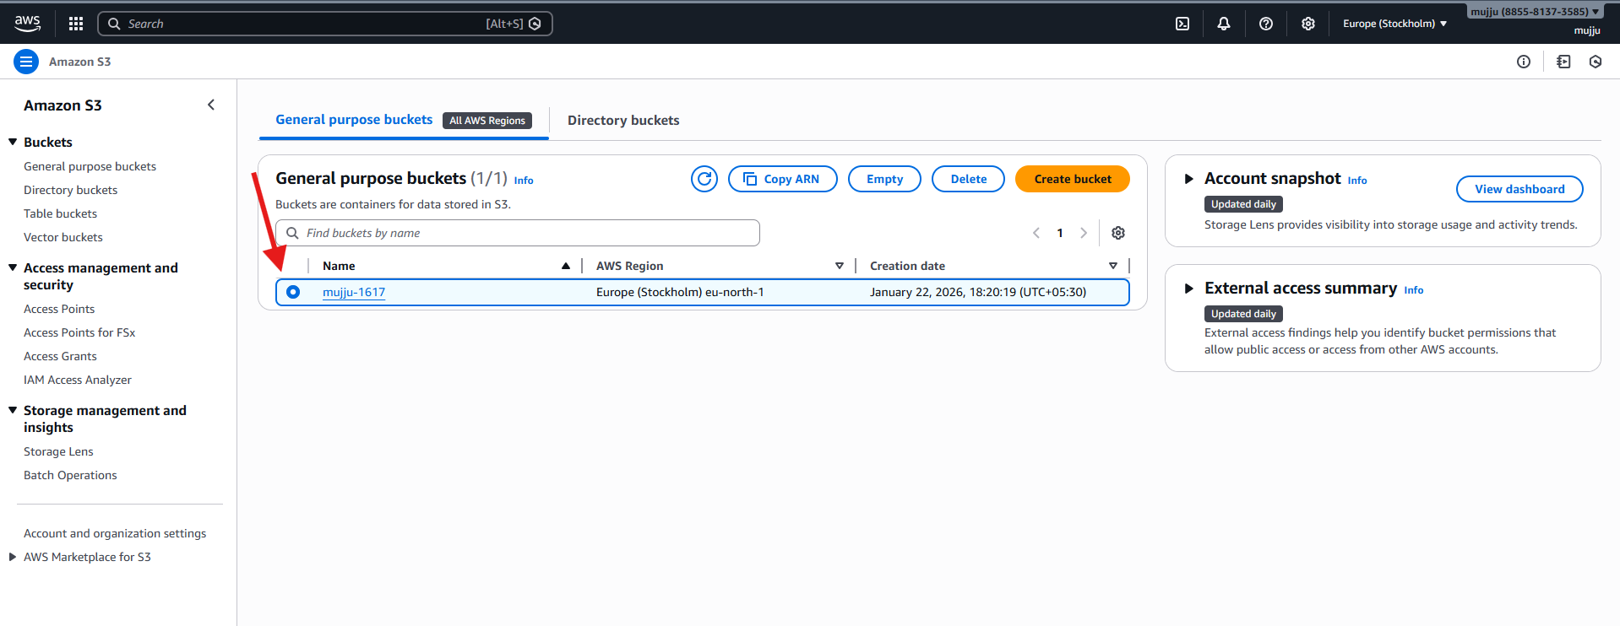

4.Provision EC2 for 3 different environments (Dev, Staging, and Prod) using Terraform workspaces.

terraform {
required_version = ">= 1.3.0"

required_providers {
aws = {
source = "hashicorp/aws"
version = "~> 5.63"
}
}
}

provider "aws" {
region = "eu-north-1"
}

locals {
env = terraform.workspace

instance_type_map = {
dev = "t3.micro"
staging = "t3.small"
prod = "t3.small"
}

instance_name_map = {
dev = "dev-ec2"
staging = "staging-ec2"
prod = "prod-ec2"
}
}

# Default VPC
data "aws_vpc" "default" {
default = true
}

# Default Subnet
data "aws_subnets" "default" {
filter {
name = "vpc-id"
values = [data.aws_vpc.default.id]
}
}

# Security Group
resource "aws_security_group" "sg" {
name = "${local.env}-sg"
description = "Security group for ${local.env} "
vpc_id = data.aws_vpc.default.id

tags = {
environment = local.env
}
}

# EC2 Instance
resource "aws_instance" "app" {
ami = "ami-0683ee28af6610487"
instance_type = local.instance_type_map[local.env]

subnet_id = data.aws_subnets.default.ids[0]
vpc_security_group_ids = [aws_security_group.sg.id]

tags = {
Name = local.instance_name_map[local.env]
environment = local.env
}
}

output "environment" {
value = local.env
}

output "instance_type" {
value = aws_instance.app.instance_type
}

output "public_ip" {
value = aws_instance.app.public_ip
}
- Open TERRAFORM_PROJECT → main.tf
- Add terraform {} block:
required_version
required_providers for AWS
- Add AWS provider configuration:
provider "aws" { region = "eu-north-1" }
- Create locals {} block to detect workspace:
env = terraform.workspace
- Create maps inside locals for environment-based values:
instance_type_map (dev/staging/prod)
instance_name_map (dev/staging/prod)
- Add default VPC data source:
data "aws_vpc" "default" { default = true }
- Add default subnet data source (filter by VPC ID)
- Start writing Security Group resource with environment tags

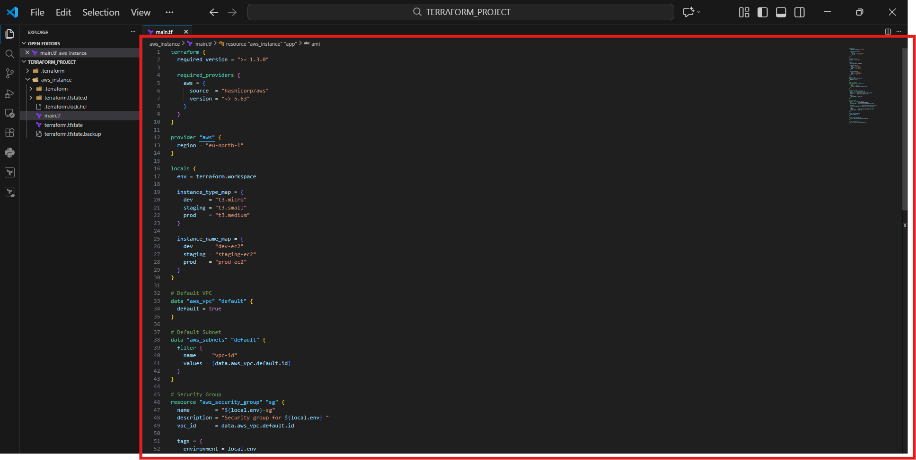
- Continue main.tf
- Complete Security Group:
name like sg-${local.env}
attach to default VPC
- Create EC2 instance resource:
resource "aws_instance" "app" { ... }
- Set AMI and dynamic instance type:
ami = "ami-0683ee28af6610487"
instance_type = local.instance_type_map[local.env]
- Set subnet from data source:
subnet_id = data.aws_subnets.default.ids[0]
- Attach security group:
vpc_security_group_ids = [aws_security_group.sg.id]
- Add tags:
Name = local.instance_name_map[local.env]
Environment = local.env
- Add outputs:
output "environment" { value = local.env }
output "instance_type" { value = aws_instance.app.instance_type }
output "public_ip" { value = aws_instance.app.public_ip }

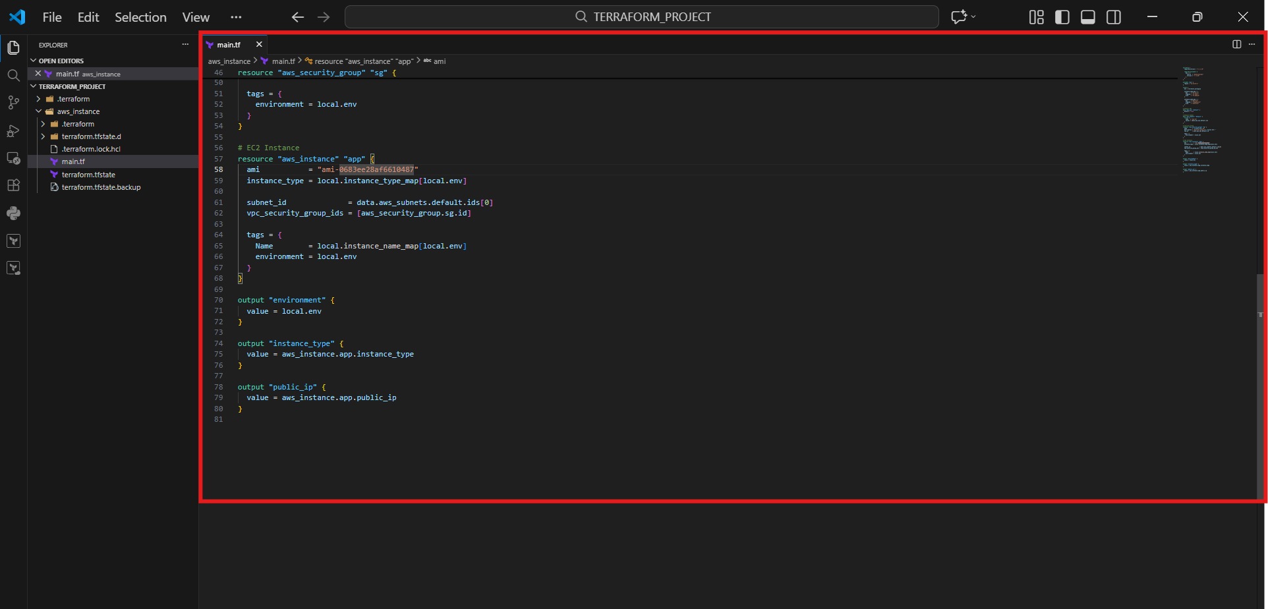
- Open terminal in project folder
- Run init with upgrade:
- terraform init -upgrade
- Run terraform plan:
- terraform plan
- You get error Invalid index (because workspace key not matching map)
- Create new workspace for dev:
- terraform workspace new dev
- Run plan again:
- terraform plan

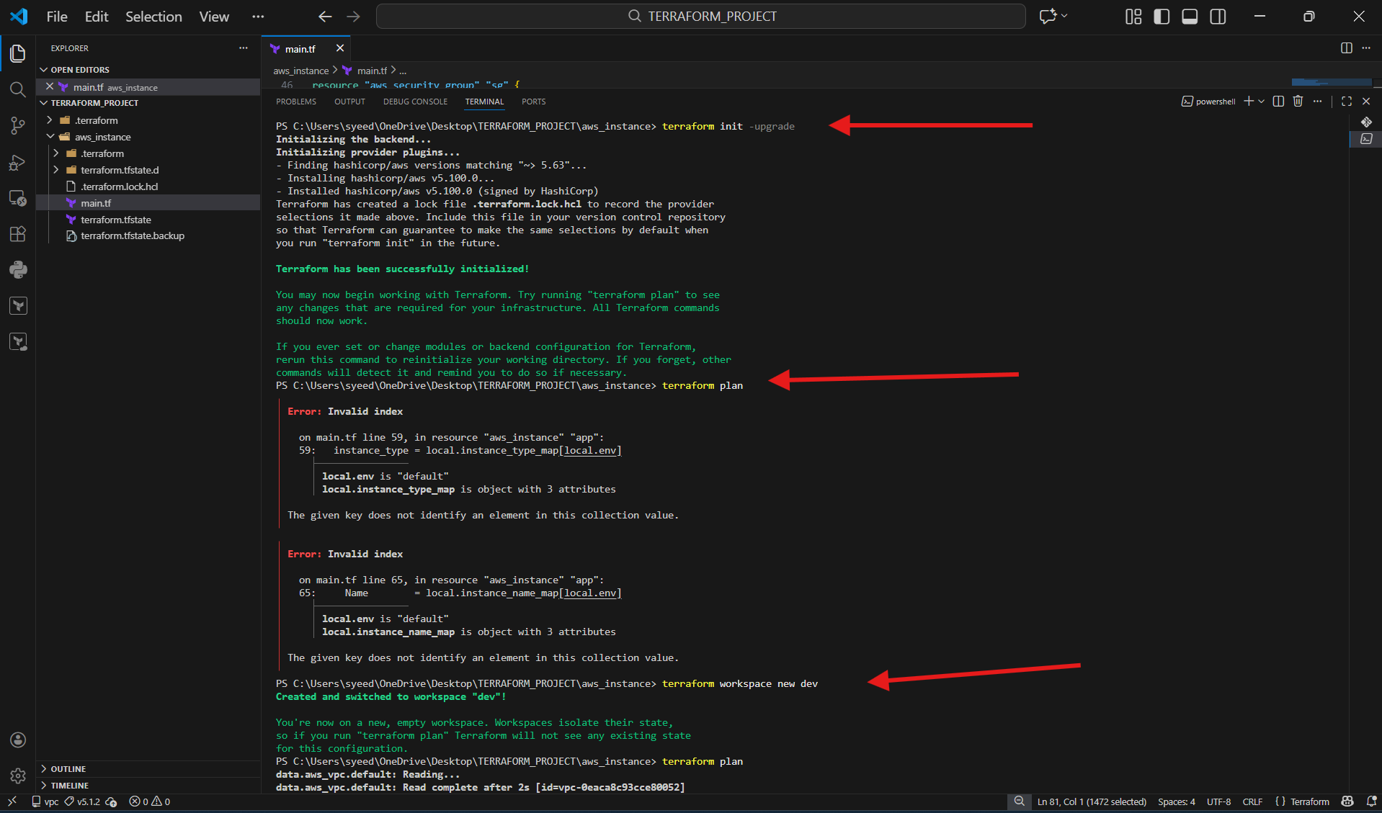
- Make sure workspace is dev
- terraform workspace show
- Apply changes:
- terraform apply -auto-approve
- Terraform creates required resources like:
- Security group
- EC2 instance

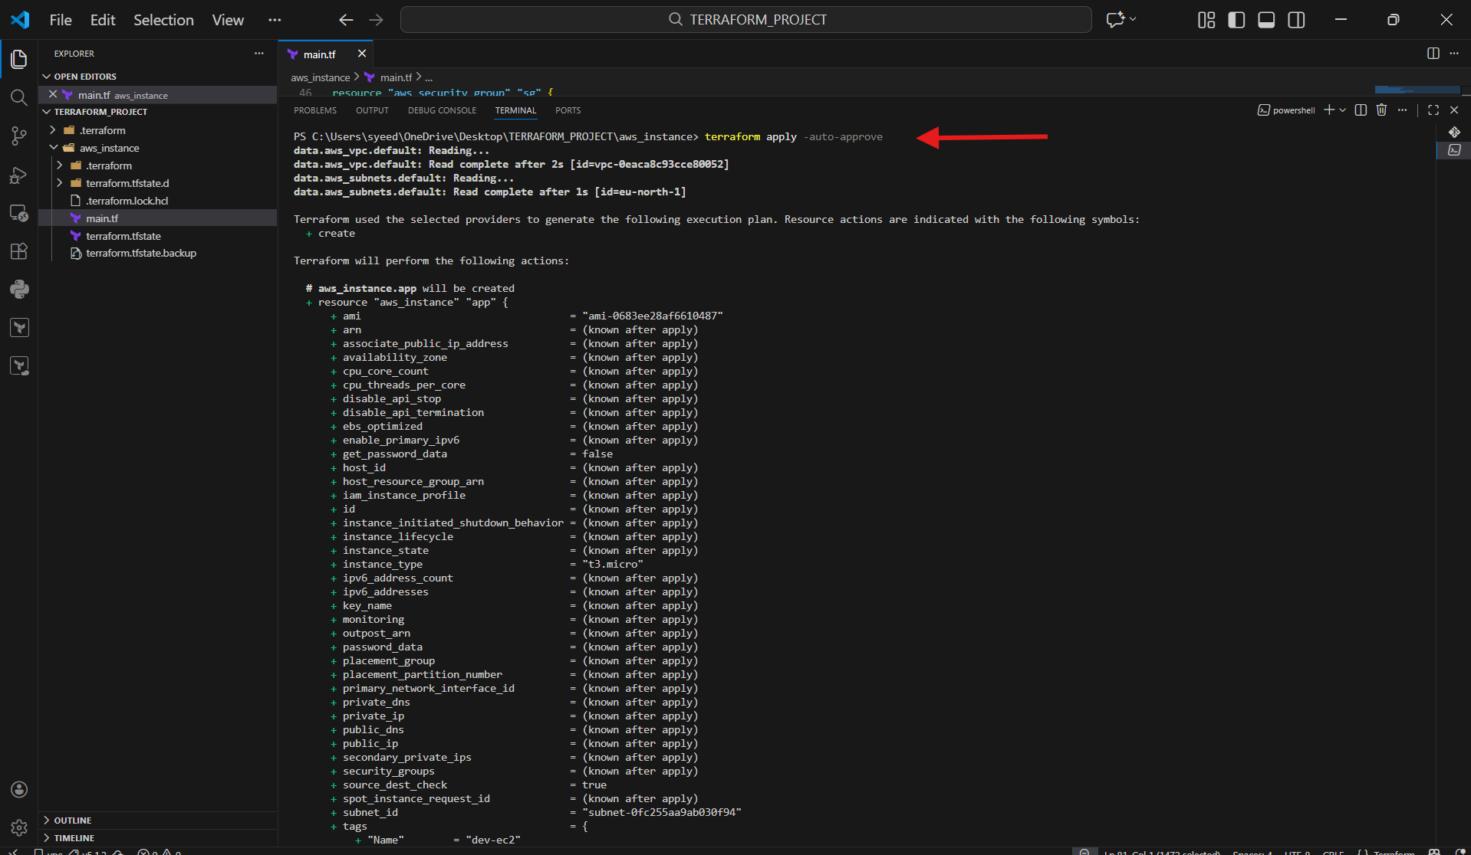
- After apply completes, confirm:
- Apply complete!
- Verify output values:
- environment = "dev"
- instance_type = "t3.micro"
- public_ip = <your dev instance IP>

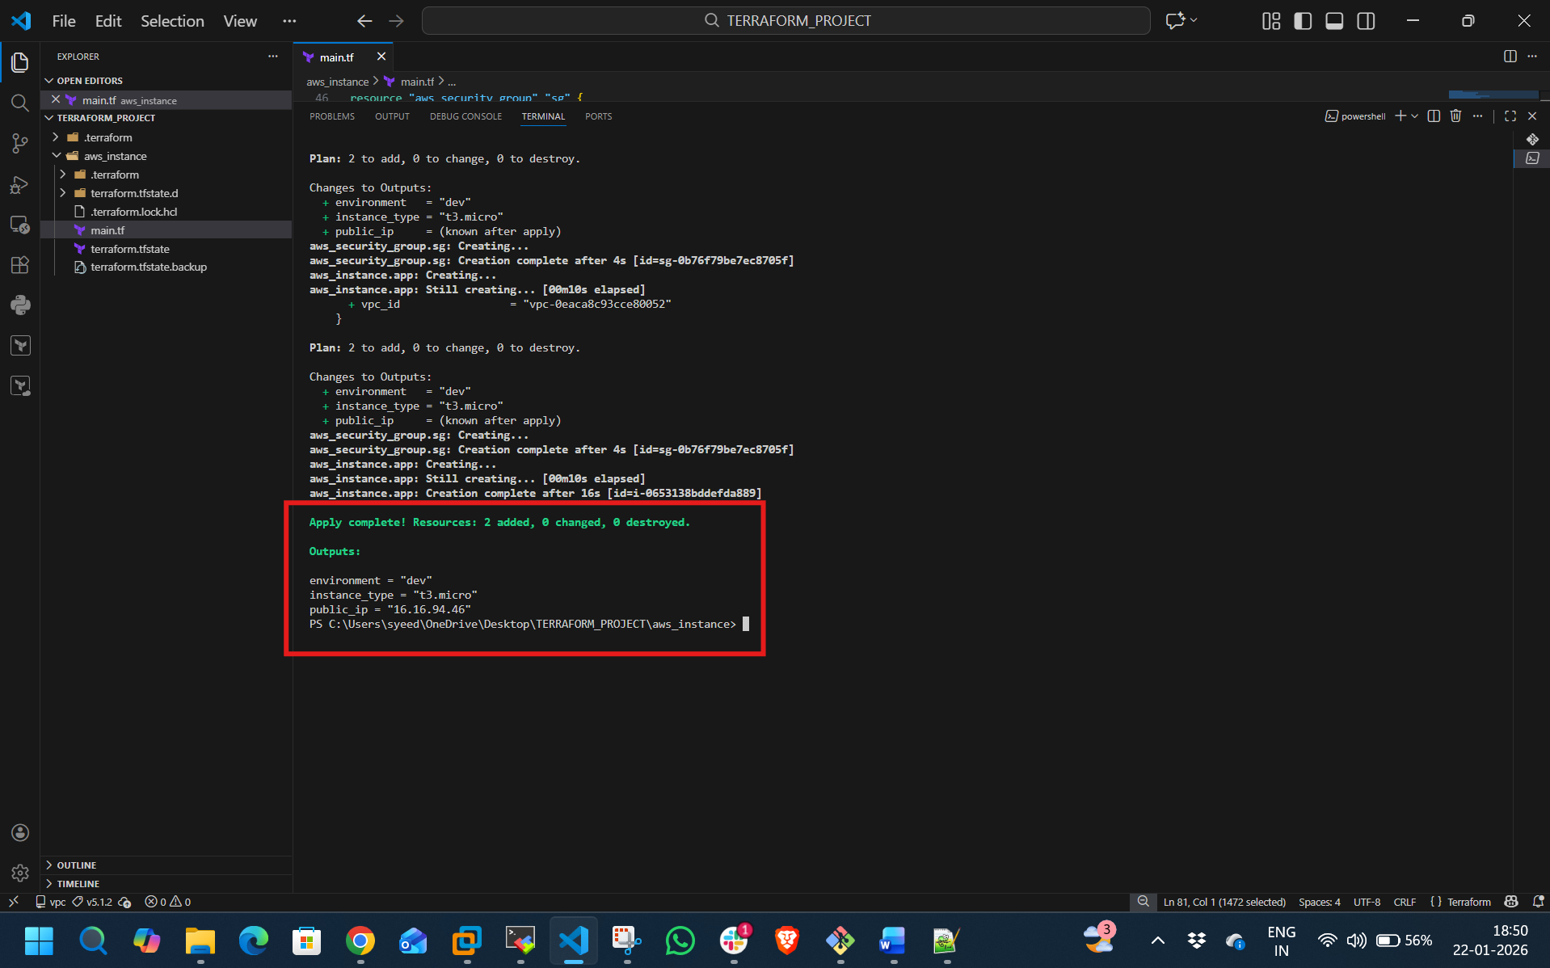
- Go to AWS Console → EC2 → Instances
- Confirm new instance is created:
Name: dev-ec2
State: Running
Instance Type: t3.micro
- Check Public IP is same as Terraform output

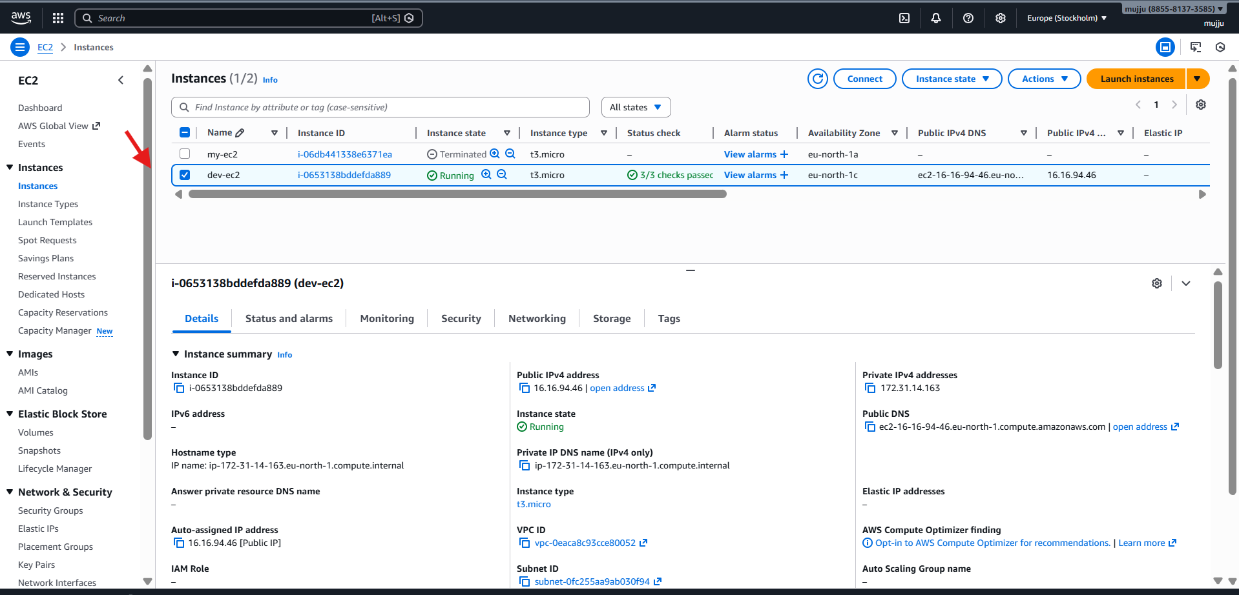
- create staging workspace:
- terraform workspace new staging
- Run terraform apply:
- terraform apply
- Review plan and type:
- yes

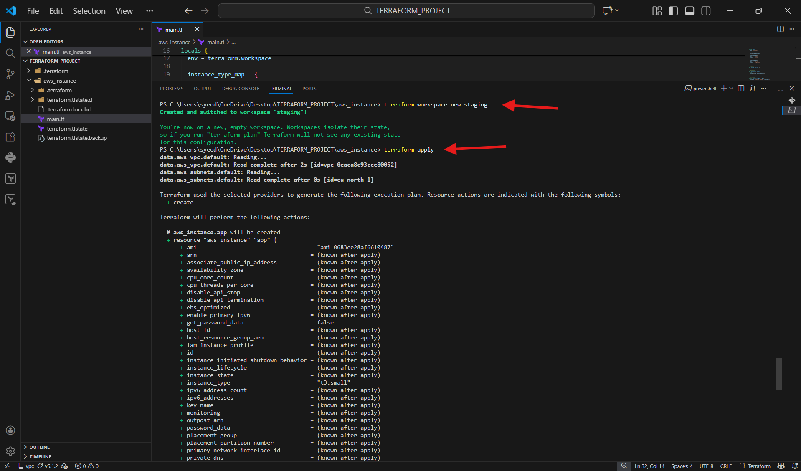
- After apply finishes, verify:
Apply complete!
- Outputs show:
environment = "staging"
instance_type = "t3.small"
public_ip = <staging IP>

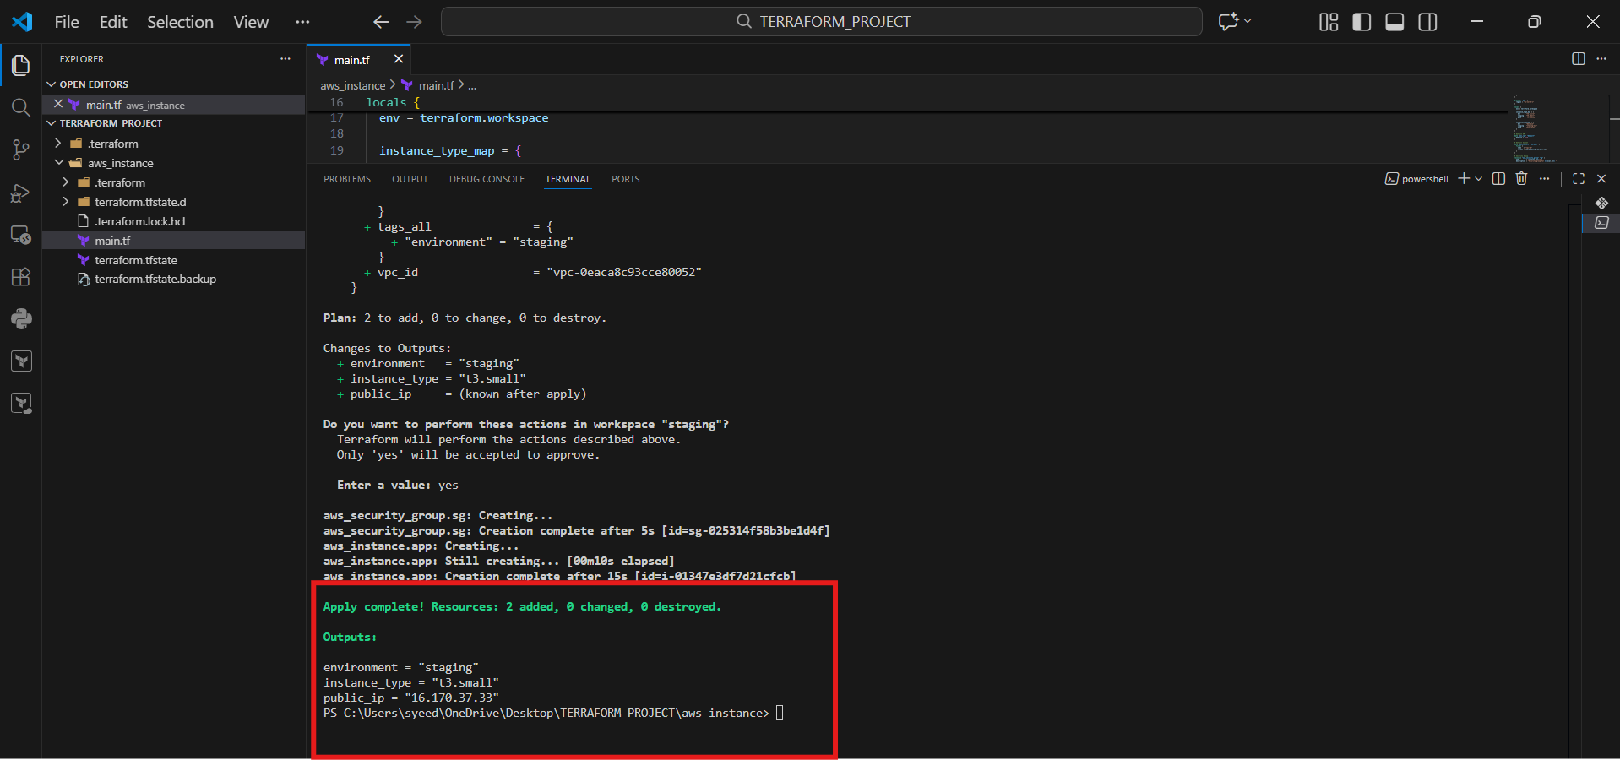
- Confirm multiple instances visible now:
dev-ec2
staging-ec2
- Check staging instance:
Instance type is t3.small
Running state

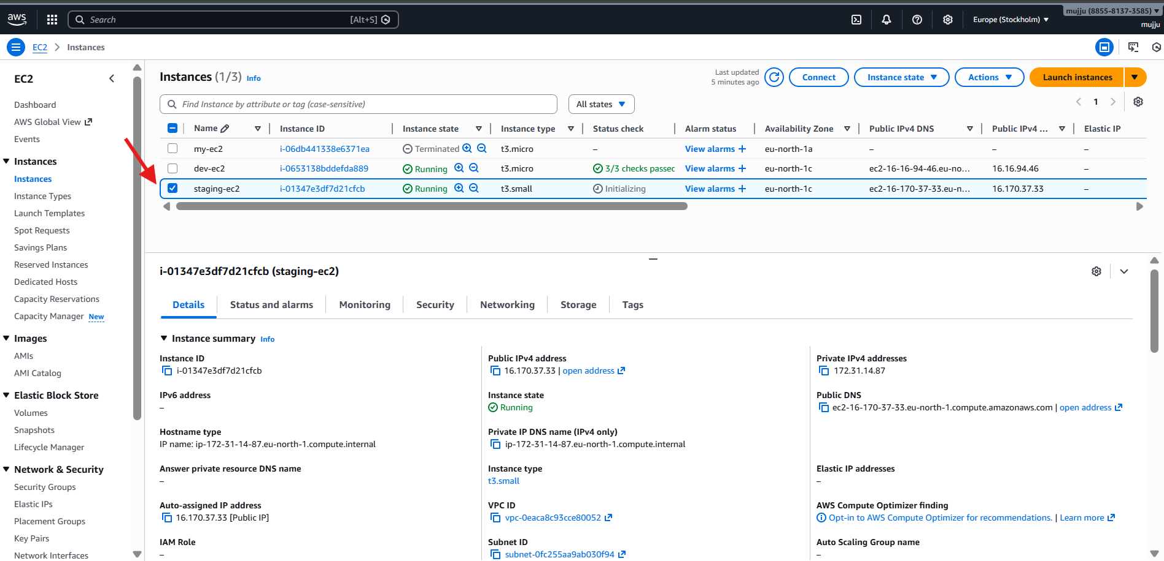
Create production workspace:
terraform workspace new prod
Run terraform apply:
terraform apply
Type:
yes
This will launch a prod EC2 based on your locals map values

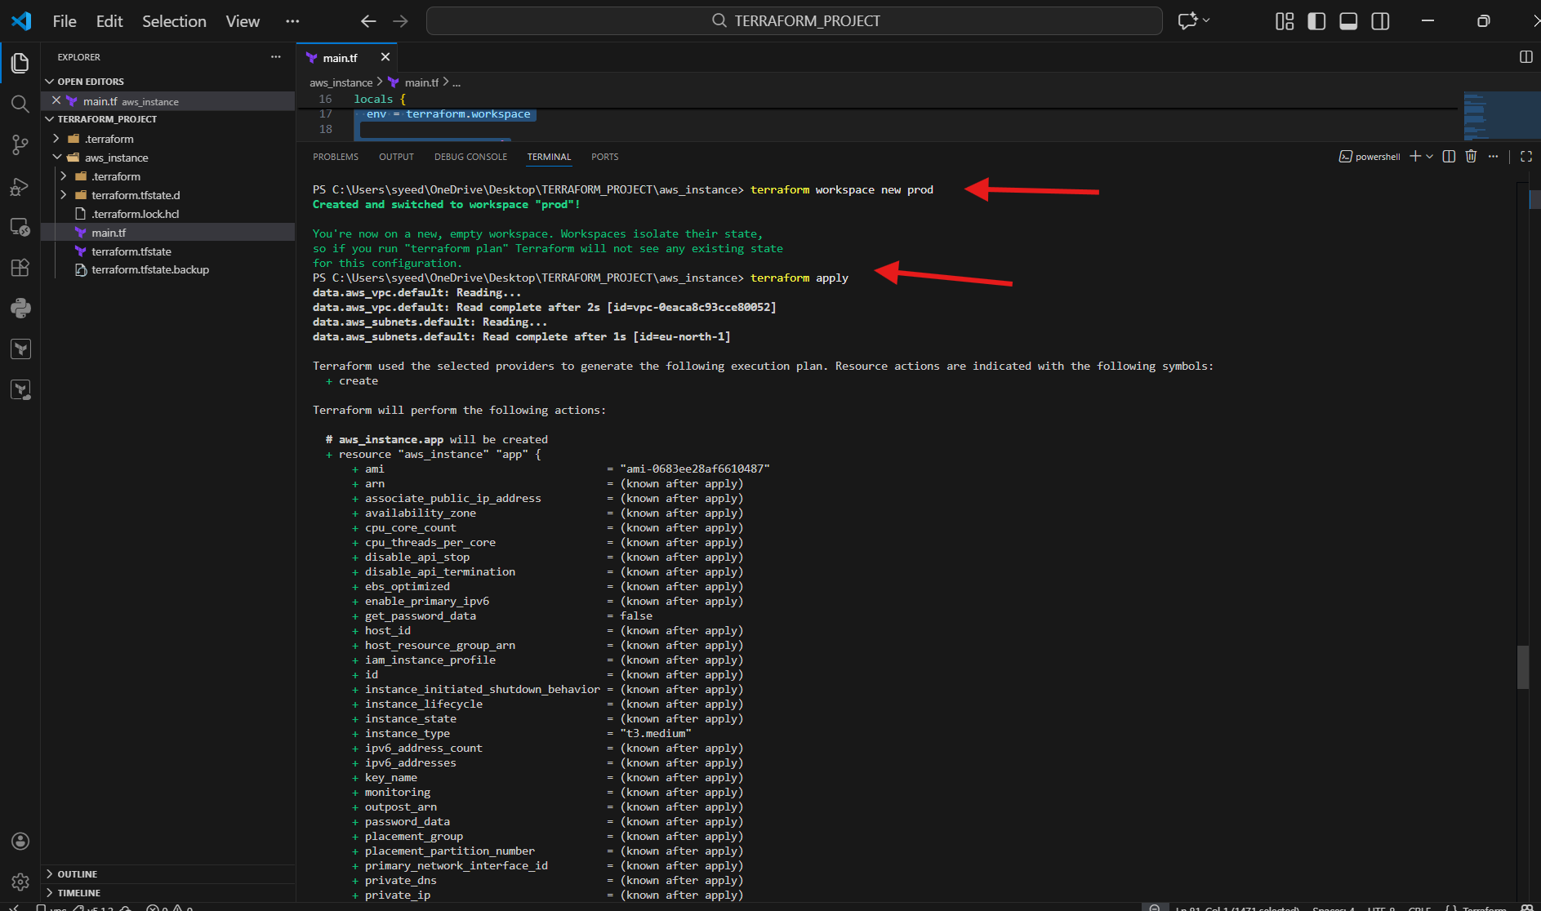
- In VS Code terminal, make sure you are in prod workspace
- Run Terraform apply:
terraform apply
- When it asks for confirmation, type:
yes
- Terraform creates the prod EC2 instance
- After completion, verify the message:
Apply complete! Resources: 1 added, 0 changed, 0 destroyed
- Check the Outputs shown:
environment = "prod"
instance_type (prod instance type from your locals map)
public_ip (public IP of prod instance)

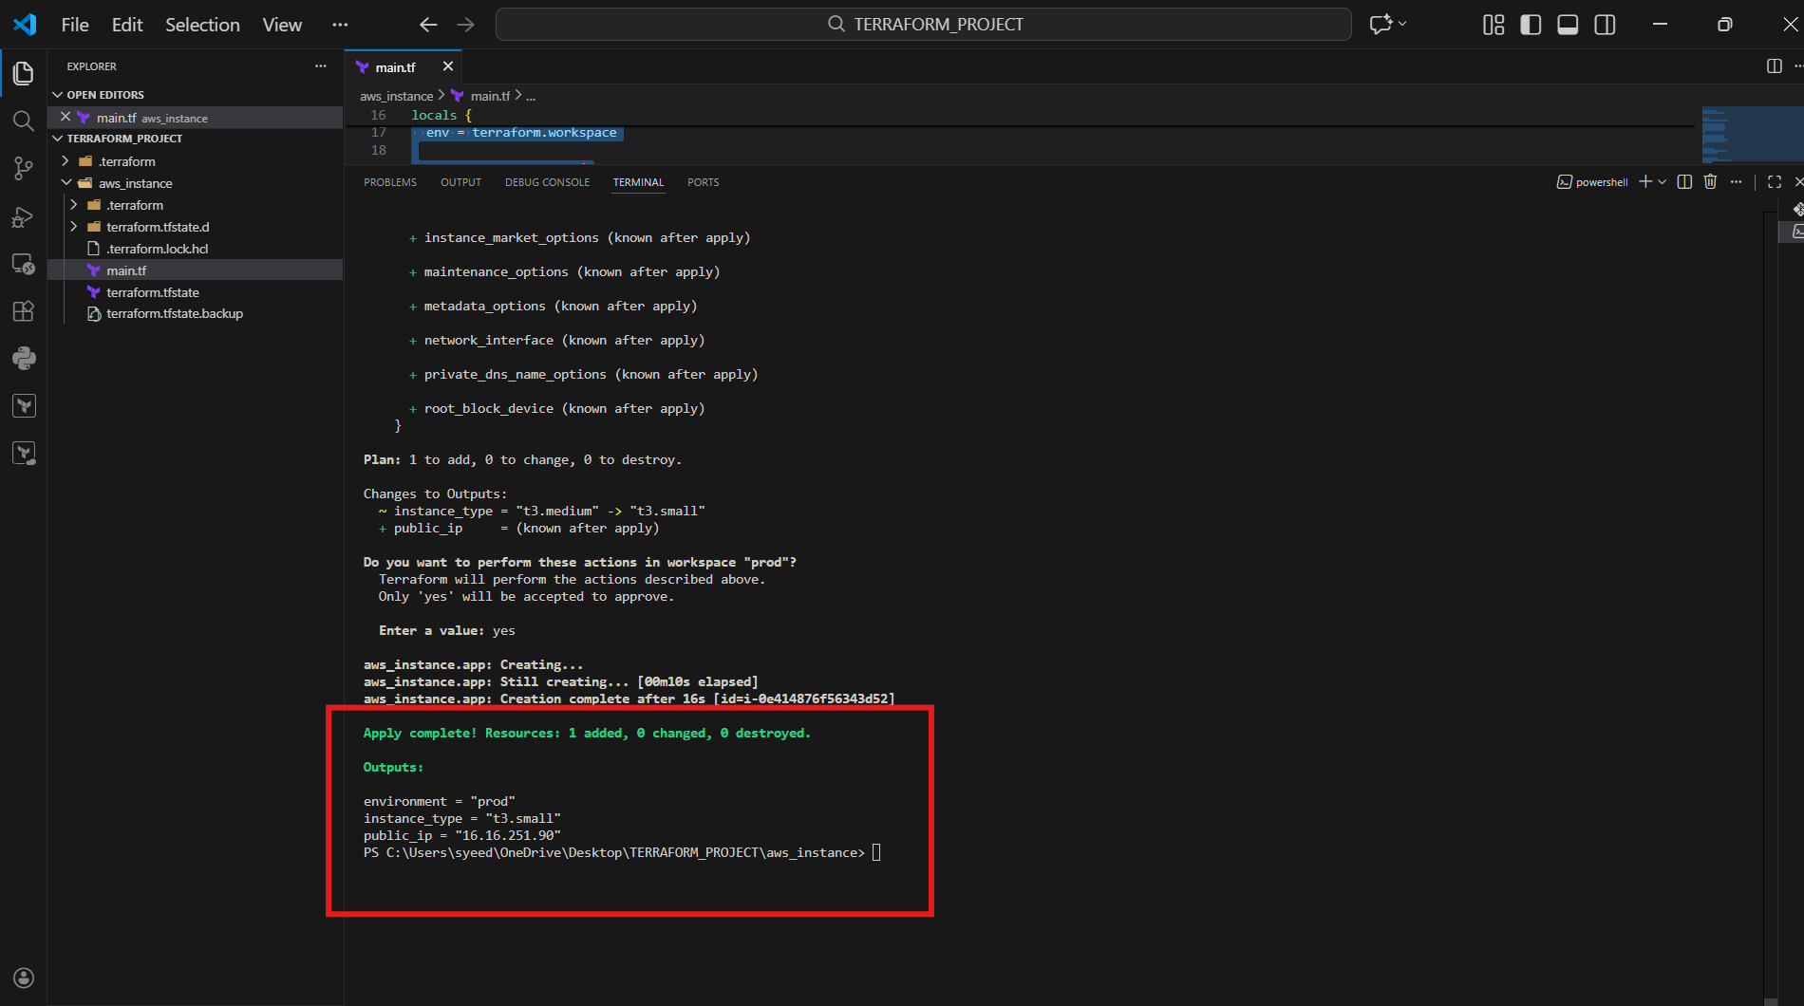
- You can now see multiple EC2 instances created from workspaces:
- dev-ec2
- staging-ec2
- prod-ec2
- Click on prod-ec2
- Confirm details:
- Instance state: Running
- Instance type matches your prod configuration
- Public IPv4 address matches Terraform output
- This confirms Terraform Workspaces successfully created separate EC2 instances for each environment

